Mine the Gap
Design Document
David Householder
Michael McCarrick
Geoff McGinnis
Will Ruck
Erik Schilling
4/19/2014

Contents
Introduction 1
Rules 2
Win Condition 2
Influence 2
Resource Income 2
Fog of War 2
Marking Mines 2
Game Modes 3
Multiplayer 3
Teams 3
The Map 3
Space 3
Anomalies 3
Black Hole 3
Generation 3
Settings 4
Planets 4
Resources 4
Units 4
Unit Movement 4
Attacking Movement 5
List of Units 5
Interceptors 5
Fighters 5
Cruisers 5
Destroyers 5
Support 6
Attack Cruisers 6
Heavy Bombers 6
Battleships 6
Carriers 6
Structures 7
Defensive 7
Missile Turret 7
Hotkeys 7
Game State Diagram 7
Credits 7
Team.GreatName 7
Resources 8
Sounds 8
Models 8
Shaders 8
Miscellaneous 8
Special Thanks 8

Introduction
Mine the Gap is the marriage of several concepts that are near and dear to our hearts: real-time strategy, Minesweeper, and space! Starting with a single capital ship and few resources, you will need to mine, build, solve and destroy to outsmart your opponent. The ultimate goal is the destruction of the opponent’s capital ship, located somewhere else in the maze of asteroids, mines and spatial anomalies.
To accomplish this goal, unique units and buildings can be constructed, each with their own benefits and weaknesses
While buildings provide a certain amount of resource generation over time, larger bounties are available to those who explore and brave the dangers of the solar system. Planets hidden in the maze provide vast resources to those who find them. Planets also provide a strategic point to launch your next exploration or daring attack
Space is a dangerous place at the best of times, and this area of it is of a particularly menacing nature. Mines of various types will tear your ships to shreds in a heartbeat if you do not learn from your mistakes and either mark them or extract them to use on your enemy. While mines are a constant danger, spatial anomalies are not part of a logical universe. Be wary of unidentified objects, creatures, and formations that lurk in the darkness of space, for they are not always as they appear.

Mine! Build! Solve! Destroy!
But above all else: Mine the Gap!

Rules

Win Condition
To complete a game of Mine the Gap and achieve victory, the player has to destroy the opponents capital ship, located somewhere else in the maze of asteroids and hazards. Exploring the maze, building units and structures, and seizing planets will all be helpful towards this goal, as they allow you to exert further pressure on your opponent.

Influence
At the beginning of the game, the player can only create structures in the area of influence around their capital ship. This sphere is indicated by a green circle that indicates the grid squares it affects. Only through the capture of a planet can you increase the amount of influence area you have to build.

Resource Income
Before any new units or structures can be created within your sphere of influence, you will need to have sufficient resources. Simpler structures and units may only require a small amount of one or two resources, while more technologically advanced ones will require a significant investment.

Fog of War
Areas of the maze that have not been explored by your units will be completely black on the screen until a unit’s vision range has seen it at least once. Different units have different vision ranges, and may or may not be able to see past a wall of asteroids. Areas that have been seen previously but are not currently within vision range will display a grayed out image of what was last seen there, but will not update to show what is currently located there, including enemy buildings or units, until it is within vision again.

Marking Anomalies
Mines are the titular and ever-present threat in Mine the Gap. There are also black holes which will suck your units in! While you will be mostly blind to where they are to start with, through trial and error, you will learn their locations. Once you have seen an anomaly, you can mark it with a small flag to tell your units to avoid the space.

Game Modes

Multiplayer
In Multiplayer mode, the player can join or host a lobby with other human opponents connecting to the game. Players work to balance exploration, expansion, and aggression to be the last man standing.

Teams
Teams are determined by the selected color. Those that choose the same color will be put on the same team against the other color. While you may choose from one of five colors, the game only supports two teams.

The Map

Space
The map takes place in space. Specifically, an extremely large asteroid field shaped as a very large maze. All units and buildings will navigate and be placed within this maze of asteroids. The player must navigate his or her way through this maze by locating intersections within the maze, and picking a direction for their units to travel.

Anomalies
Spatial anomalies are scattered around the map. These anomalies act in a similar fashion to mines, but create different effects when compared to a mine. In general these locations should be marked for your units to avoid in a similar fashion to mines. Not all anomalies will be visible, stationary, and some may disappear after a unit travels through its space, or after a short period of time.

Black Hole
Black holes act in a similar fashion to mines in that they will destroy any ships that get to close to them. The biggest difference is that they are visible.
Mines
A far more sinister threat than black holes, surprisingly. Mines are littered around the map, with the important distinction that they are invisible, and there is no chance to mark a mine before it kills your units, as there is with black holes.

Generation
Maze and map generation is handled with a depth-first search maze generation algorithm, with a degree of overlap so that cycles and dead-ends are prevalent for challenging complexity. For larger maps, “maze within a maze” generation is used to make chunks of the maze their own maze as it were, with exits being used to interlace with other maze chunks.

Settings

Map Size
The overall map size is determined by the width and height sliders. These are then expanded further with the maze thickness. Only the host has access to these options.

Maze Thickness
This is how thick each square in the generated maze becomes after maze generation. For instance, if the maze is generated as a 10x10 grid, and it has a maze thickness of 2, the generated map will be of size 20x20.

Planets
Planets are scattered throughout the maze and provide a valuable asset in defeating your opponent. Planets can provide a secondary staging point for units and extra resources. Upon capture, planets will provide an area of influence similar to the one provided by your carrier but also generate 16 resources per 10 seconds. This is higher than any building in the game and can be a significant advantage early on.
To capture a neutral planet, simply bring a ship near it will begin to convert to your team. If it is owned by an enemy, you will need to bombard the planet's surface until it is yours.

Resources
There is only one resource currently in Mine the Gap. This resource is used to purchase buildings. There is however a pseudo-resource that exists. Since a player can only build in their areas of influence, they must take care not to waste space and use it wisely.

Units

Unit Movement
When a unit is spawned, it will move to the nearest waypoint node to the factory. Once it has reached this waypoint, it will move in the direction that the waypoint is set. If the waypoint does not have a direction set, the unit will wander in a random direction towards a nearby waypoint.
To set the waypoint direction simply highlight the node (a small sphere), which will cause four arrows to pop up. You can then shift select the direction you wish to start sending units. To hide the arrows, simply click away from the waypoint to deselect it.

Attacking Movement
If a unit gets within the agro range of a unit, it will begin to chase that unit until the unit is either destroyed, or it is no longer within its agro range. Once this happens, the unit will navigate back to the waypoint it was headed towards and continue on like normal.

List of Units

Interceptors
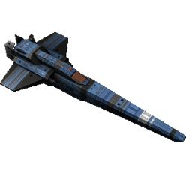
HP: 45
Armor: 0
Damage: 8
Speed: 1.33
Attack Speed: 0.6
Attack Range: 3

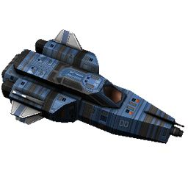
Fighters
HP: 55
Armor: 0
Damage: 14
Speed: 1.1
Attack Speed: 0.8
Attack Range: 2.5

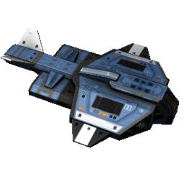
Cruisers
HP: 120
Armor: 1
Damage: 17
Speed: 1
Attack Speed: 1.2
Attack Range: 3.5

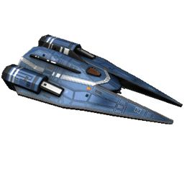
Destroyers
HP: 85
Armor: 1
Damage: 10
Speed: 1.8
Attack Speed: 0.15
Attack Range: 0.5

Support
This unit is a mid to late game unit. It is the only unit capable of healing friendly units and can cause a unit to survive well past its prime.
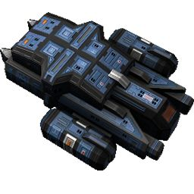
HP: 90
Armor: 1
Healing: 8/sec
Speed: 1
Healing Speed: 0.2
Healing Range: 4

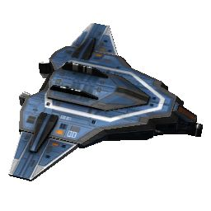
Attack Cruisers
HP: 150
Armor: 2
Damage: 25
Speed: 1
Attack Speed: 0.8
Attack Range: 5

Heavy Bombers
This unit is an end game unit. It has extremely long range and high damage. It is also the only unit with an attack that will hit multiple units. It is great for clearing out waves of enemies.
HP: 175
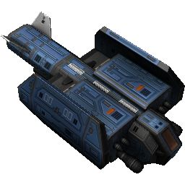
Armor: 2
Damage: 40
Speed: 0.9
Attack Speed: 3
Attack Range: 8

Battleships
HP: 250
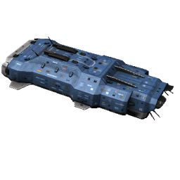
Armor: 3
Damage: 50
Speed: 0.75
Attack Speed: 2.1
Attack Range: 6

Structures
With the exception of the missile turret, all buildings have 1000 health and 3 armor.

Main Carrier

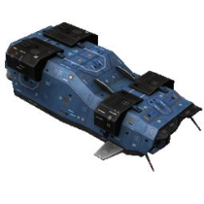
Your main base. If this dies, you lose.
HP: 2000
Build Time: 25
Resource Gen: 0.75/s

Defensive

Missile Turret
The missile turret does not have as much health as most buildings, but can attack enemies within a certain radius. This building does not produce resources.
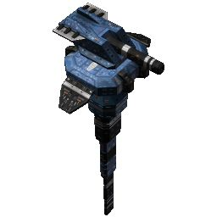
Cost: 150
HP: 250
Armor: 3
Damage: 25
Attack Speed: 1.2
Attack Range: 6

Unit Factories

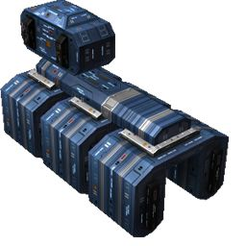
Interceptor Factory
Cost: 30
Build Time: 20
Resource Gen: 0.1/s

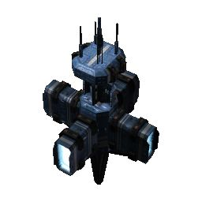
Fighter Factory
Cost: 50
Build Time: 20
Resource Gen: 0.2/s

Cruiser Factory
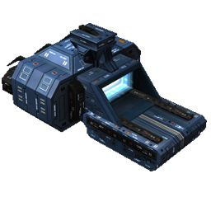
Cost: 100
Build Time: 30
Resource Gen: 0.4/s

Destroyer Factory
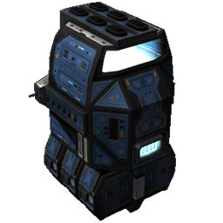
Cost: 150
Build Time: 30
Resource Gen: 0.6/s

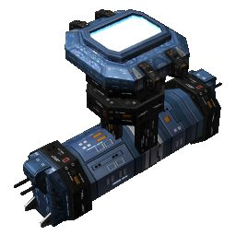
Support Factory
Cost: 125
Build Time: 40
Resource Gen: 0.5/s

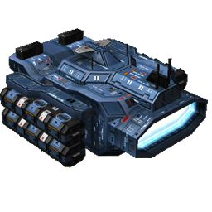
Attack Cruiser Factory
Cost: 150
Build Time: 40
Resource Gen: 0.6/s

Heavy Bomber Factory
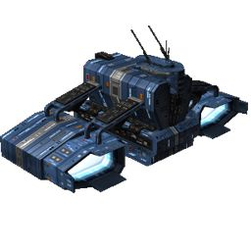
Cost: 175
Build Time: 40
Resource Gen: 0.7/s

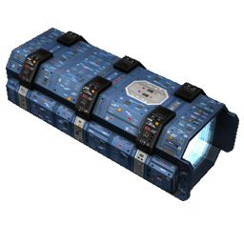
Battleship Factory
Cost: 200
Build Time: 60
Resource Gen: 0.8/s

Hotkeys

F Key: If a single unit is selected, the camera will follow that unit for as long as F is held.
C Key: Snaps the camera back to the carrier.
Backspace: Delete selected buildings (will not delete the main carrier).
ESC Key: Reset the build timers of all selected buildings.

Game State Diagram
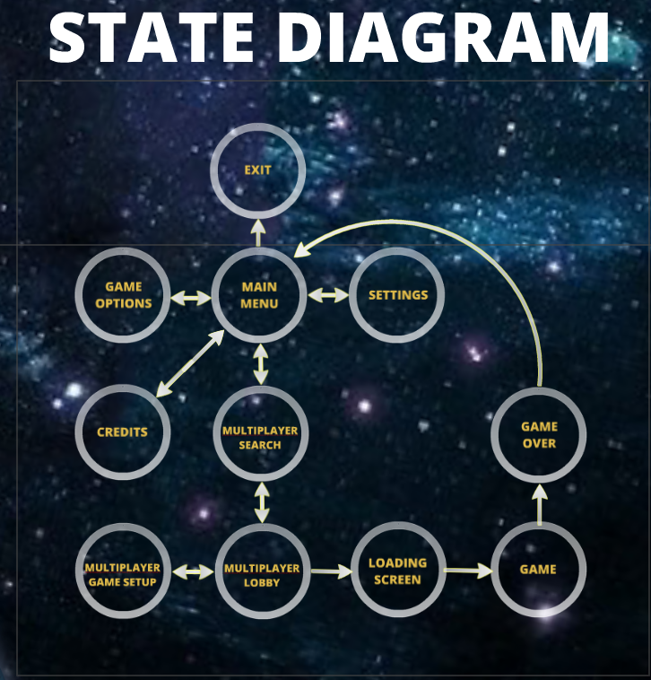

Credits

Team.GreatName
David Householder
Michael McCarrick
Geoff McGinnis
Brett Mugglin
Will Ruck
Erik Schilling

Resources
A* Path Finding - http://arongranberg.com/astar/
Fog of War - http://u3d.as/content/tasharen-entertainment/tasharen-fog-of-war/3du

Sounds
Place building: https://www.freesound.org/people/mtadder/sounds/99218/
Big Laser: https://www.freesound.org/people/taren1965/sounds/132502/
Button select in menus: https://www.freesound.org/people/peepholecircus/sounds/171705/
Change to another menu: https://www.freesound.org/people/cselman/sounds/59275/;
Place flags: https://www.freesound.org/people/Corsica_S/sounds/69897/
Remove flags: https://www.freesound.org/people/NoiseCollector/sounds/41901/
Glorious Morning - http://www.newgrounds.com/audio/listen/91476

Models
http://www.blendswap.com/blends/view/17601
https://www.assetstore.unity3d.com/#/content/12840
https://www.assetstore.unity3d.com/#/content/12919
https://www.assetstore.unity3d.com/#/content/13792
http://unity3d.com/learn/tutorials/projects/space-shooter
Explosions - http://u3d.as/content/ben-throop/detonator-explosion-framework/1qK
Energy Bar Toolkit - http://redmine.madpixelmachine.com/projects/energy-bar-toolkit-public/wiki
Loading Background - http://www.betterwallpaper.com
Overlay Texture - commons.wikimedia.org
Dogecoin (much wow) - http://minus.com/mbdwEbyAUPkk5R

Shaders
http://wiki.unity3d.com/index.php?title=Planet
http://wiki.unity3d.com/index.php/Earth/Planet

Miscellaneous
Asteroid Icons - http://game-icons.net/
StackOverflow - http://stackoverflow.com/
Unity Answers
Garage Band - https://www.apple.com/mac/garageband/
Blender - http://www.blender.org/
Photoshop - http://www.photoshop.com/
Prezi - http://prezi.com/

Special Thanks
Dr. Roger Crawfis
David Householder for his hospitality

